DATE: 18.01.2019
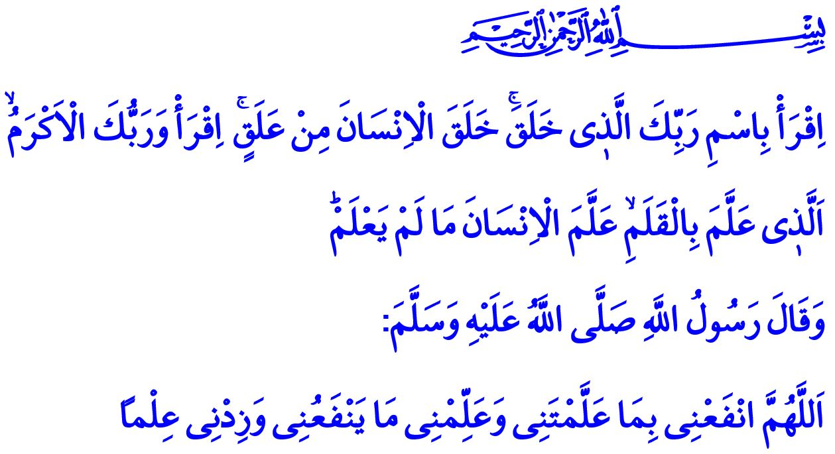
MUSLIMS ARE PRECURSORS OF KNOWLEDGE AND CIVILIZATION
Honorable Muslims!
The verses I have recited were the first revelation to our Beloved Prophet (saw), who was sent as a guide to humanity, and as a mercy to the worlds. These verses of the Holy Qur’an, which were the first to be revealed, invited all Muslims to the path of knowledge and wisdom in the person of our Prophet (saw) as: “Recite in the name of your Lord who created - Created man from a clinging substance. Recite, and your Lord is the most Generous - Who taught by the pen - Taught man that which he knew not.”
Esteemed Believers!
Being the addressee of the revelation and being equipped with knowledge are the most precious features of human in the realm of existence. Indeed, the Holy Qur’an informs us that Allah the Almighty (swt) taught the names and the verity of all things to the first prophet and first human Adam (as), “…And He taught Adam the names - all of them...”
The ability to learn and teach is a rare blessing bestowed upon human by Allah the Almighty, who is “al-Aleem (the All-Knowing)”. The greatest effort worthy of exhaustion for humans is to feed the soul by pursuing authentic knowledge just as they feed themselves physically by pursuing the halal (lawful) means of earning. Can one think of a more valuable effort than accumulating knowledge or a more honorable rank than being a scholar? Can those who turn their back on the light of knowledge find peace? For this reason, our Prophet (saw) warned us, “You should be a teacher or a learner, a listener or a supporter of knowledge, and you should not be the fifth, which makes you perish!”
Valued Muslims!
Islamic civilization, which has been carrying justice, compassion, peace and trust to all corners of the world since ‘Asr al-Sa’adah (Age of Bliss), is a civilization of knowledge. It is so because Islam commands human—who shoulders the trust of Allah (swt) on earth—to think, produce knowledge, and contribute to the improvement of themselves and the society by learning the truth.
As the adherents of a religion as such, and with the inspiration they take from the Holy Qur’an that clearly expresses, “Those who know would not be equal to those who do not.”, Muslims have been the pioneers of knowledge in all the geographies they live. They have taken groundbreaking steps in sciences such as medicine, algebra, chemistry and geometry, physics and astronomy in particular, as well as the fields such as the Qur’anic exegesis (tafsir), hadith, Islamic jurisprudence, and kalam. They brilliantly established a bond between the unshakable principles of the religion they believe and the marvelous rules of the universe they live. They have become the followers of a path that will lead humankind to peace in this world and to salvation in the Hereafter by combining physics with metaphysics, and knowledge with wisdom. They have authored many masterpieces that have put their stamp on history and they have enlightened both their own era and the following centuries with their knowledge and inventions.
Honorable Muslims!
With the sorrows that hurt all our hearts, the Islamic world that is going through difficult times today is paying off the price of neglecting knowledge and contenting with ignorance. Making up for being left behind in that regard and building a peaceful and safe future can only be possible through acquiring knowledge.
Knowledge is such a great force—people with good intentions can turn it into benefits for humanity while people with bad intentions can turn it into a lethal technology that can kill millions of people. Then, our duty as Muslims is to know the value of knowledge, and to introduce “ethics of knowledge” to our present day so that the knowledge can produce goodness. We need to fully grasp the sense of the responsibility that our faith and history places on us, and strive to become a society that reads, contemplates, inquires, and refers to authentic sources to acquire knowledge. We need to embrace knowledge to protect our tomorrows from material and spiritual destruction, with the awareness that we do not have even a second to waste. We need to ensure that our children who are the light of our eyes become familiar with the prominent figures of our civilization, and teach them that it was Muslim scholars who laid the foundations of modern sciences and technological discoveries hundreds of years ago. We need to introduce those prominent figures as role models, who used their knowledge, experience, reasoning, and efforts for the good of humanity.
Esteemed Believers!
Our Prophet (saw) supplicated to our Lord, as I recited at the beginning of my khutbah, “O Allah, benefit me with that which You have taught me, and teach me that which will benefit me, and increase me in knowledge.” It is essential for Muslims to have beneficial knowledge and do good deeds. Today, too, just as has been throughout the history, Muslims all around the world continue to acquire knowledge, carry out learning and teaching activities, and strive to be the pioneers of all kinds of charitable works, as well as reconstruction, improvement, and building activities. In 2018, we inaugurated the Imam Sarakhsi Mosque in Bishkek, Kyrgyzstan, and the Cologne Mosque in Germany, with the help of our charity-loving nation. In 2019, inshaallah, the adhans will echo, the believing hearts will line up standing shoulder to shoulder in prayer, and the foreheads will meet the ground in prostration at the Hala Sultan Mosque in the Turkish Republic of Northern Cyprus, the Tirana Mosque in Albania, and the Sultan Abdulhamid Khan Mosque in Djibouti. May our Lord always give our noble nation all in abundance, who always support knowledge and worship places. May our Lord accept all our charitable works in the best fashion.

Alaq, 96/1-5.
Baqarah, 2/31.
Darimi, Muqaddimah, 26.
Zumar, 39/9.
Tirmidhi, Da’awat, 128. General Directorate of Religious Services

